Assignment –7 Summarizing Data with Aggregate Functions.

1. Write a query that counts all orders for October 3

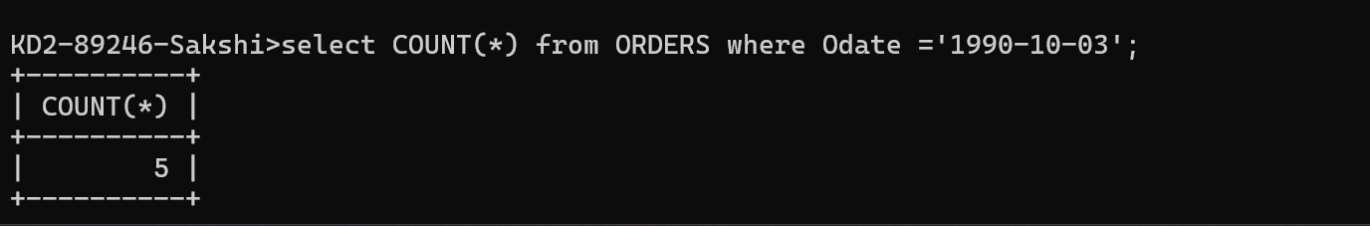

1. Write a query that counts the number of different non-NULL city values in the Customers table.

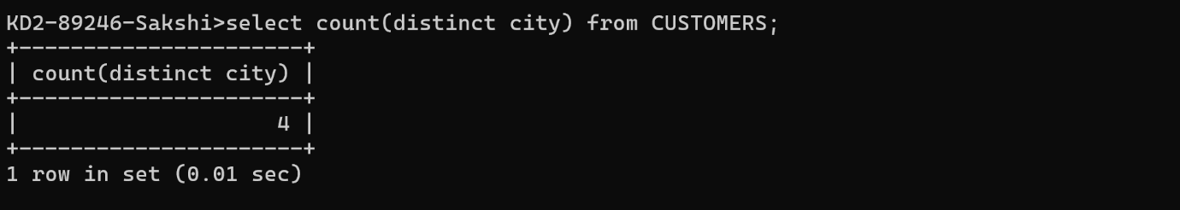

3) Write a query that selects each customers smallest order

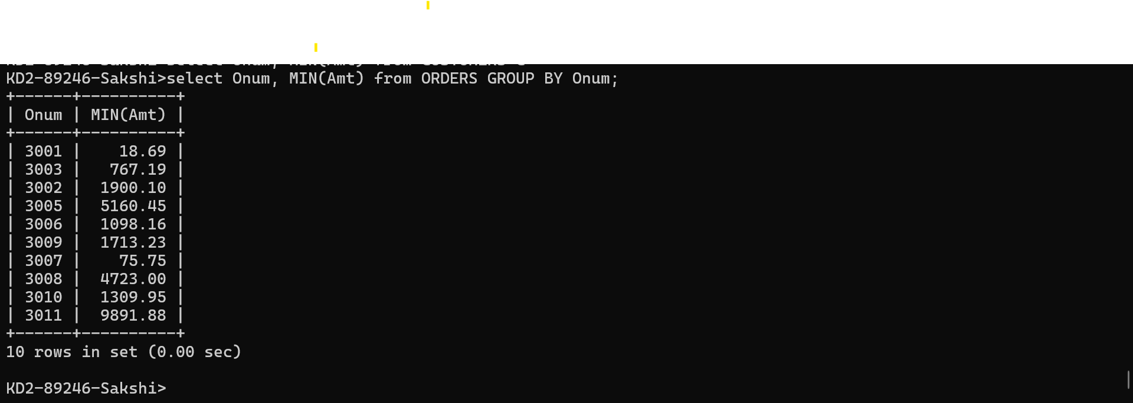

1. Write a query that selects the first customer, in alphabetical order, whose name begins with G.

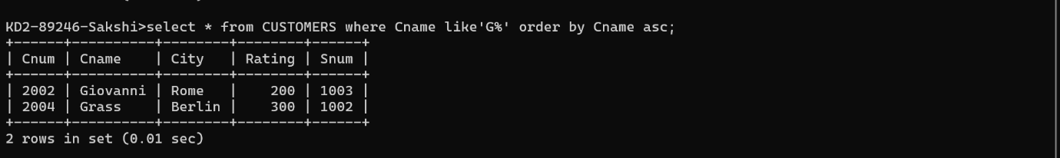

5) write a query that selects the highest rating in each city

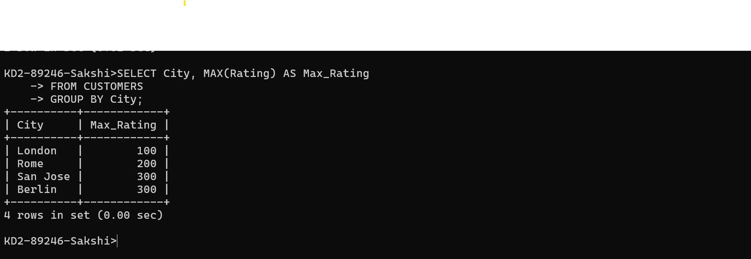

6) Write a query that counts the number of salespeople registering orders for each day. (If a salesperson has more than one order on a given day, he or she should be counted only once.).

